**Acceptance Test cases**

**HOME PAGE**

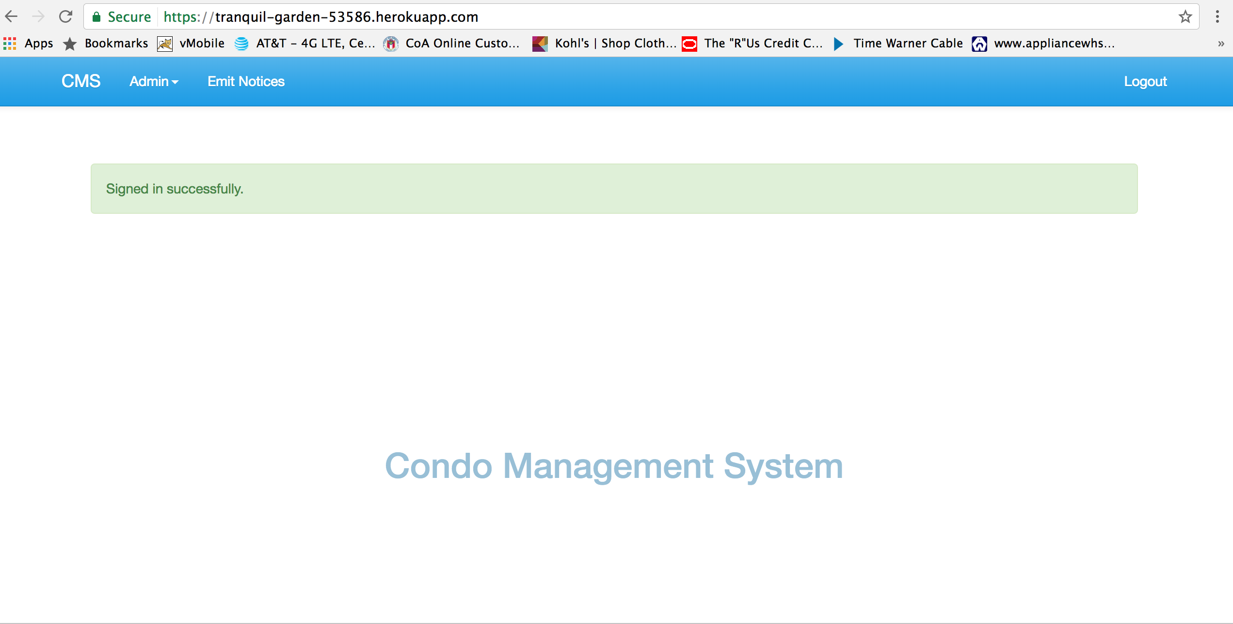

CREATING A CONDO

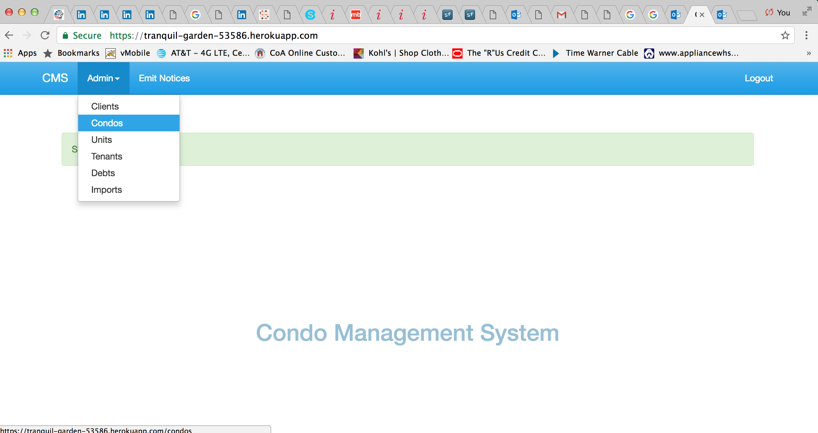

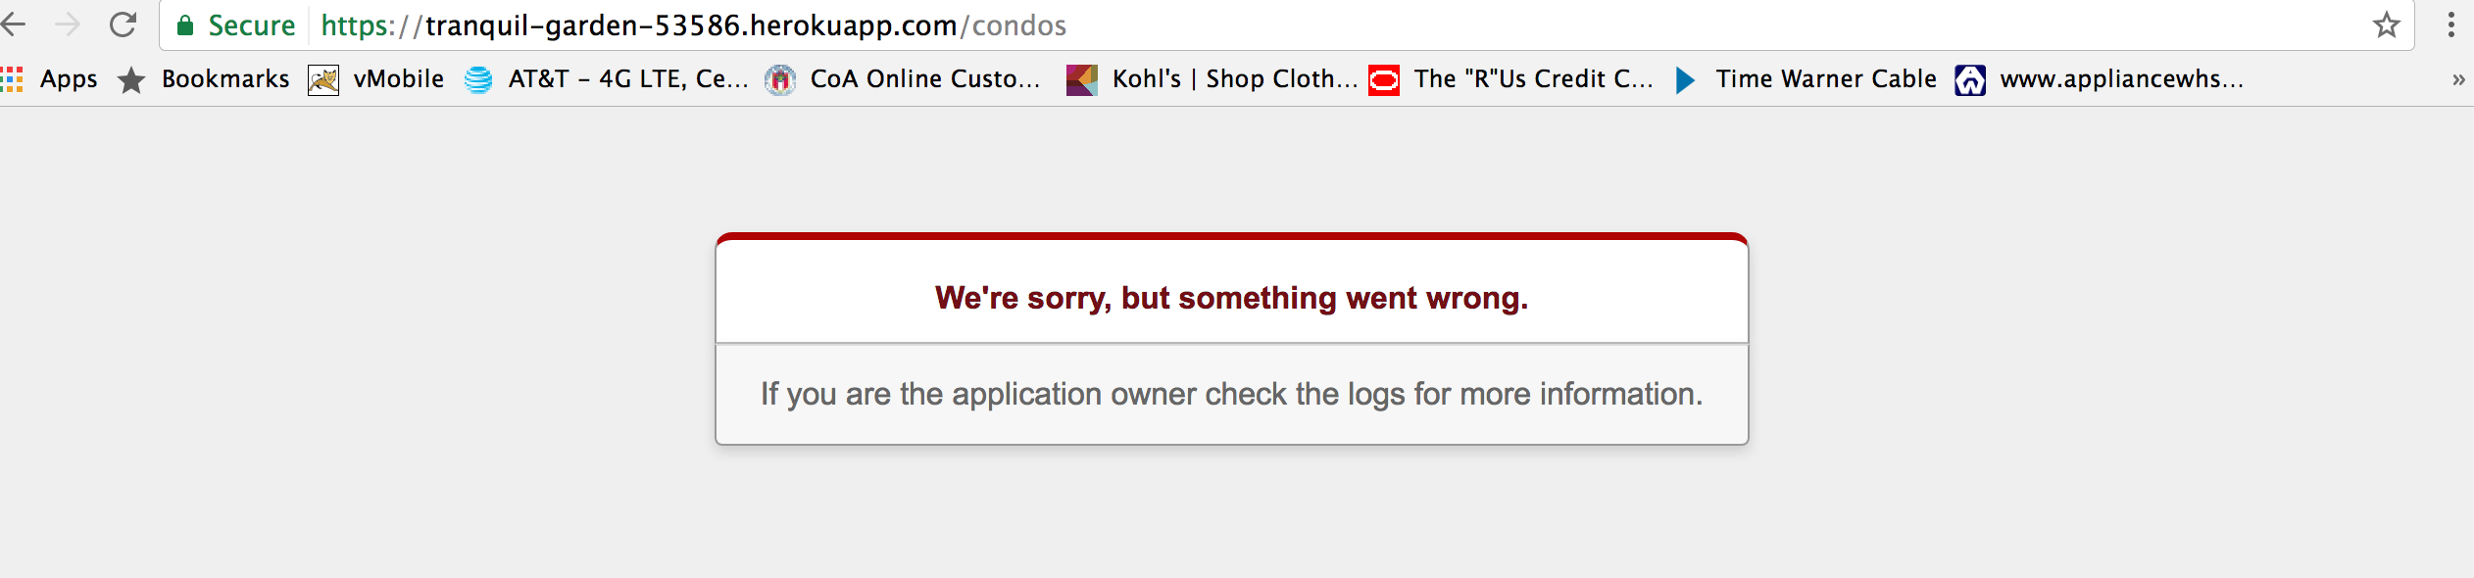

DISPLAY THE LIST OF ALL UNITS

Name: Display list of units

Trigger: User Interaction with CMS window

Precondition: Assert that user has logged in

Path:

1. User clicks on units from the Admin drop down menu.

Requirements

1. All the allocated units should be displayed.

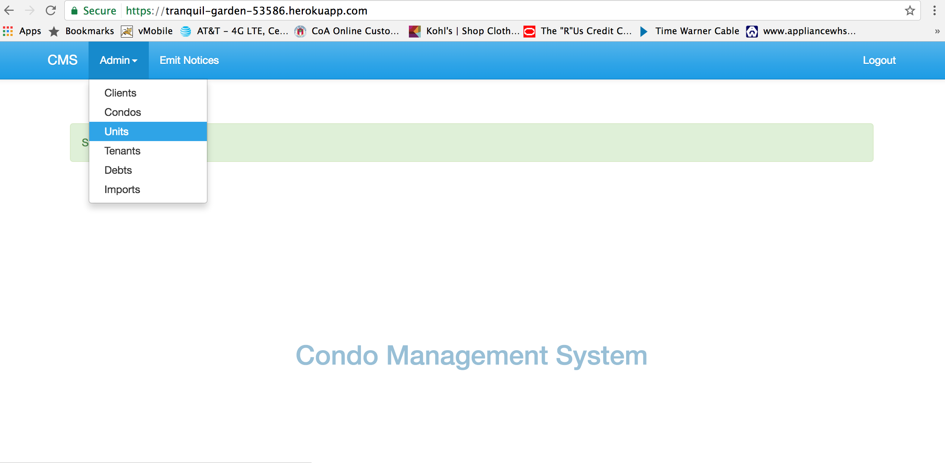

LIST OF UNITS

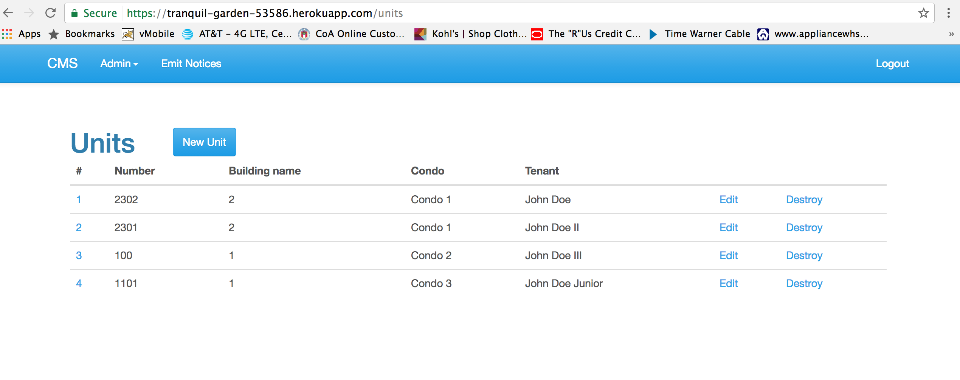

CREATING NEW UNIT

Precondition: Assert that user has logged in

Path:

1. User clicks on units from the Admin drop down menu.
2. User clicks on the New unit button.
3. User fills the Unit number and other details.
4. Click on create Unit.

Requirements

1. All the allocated units should be displayed.

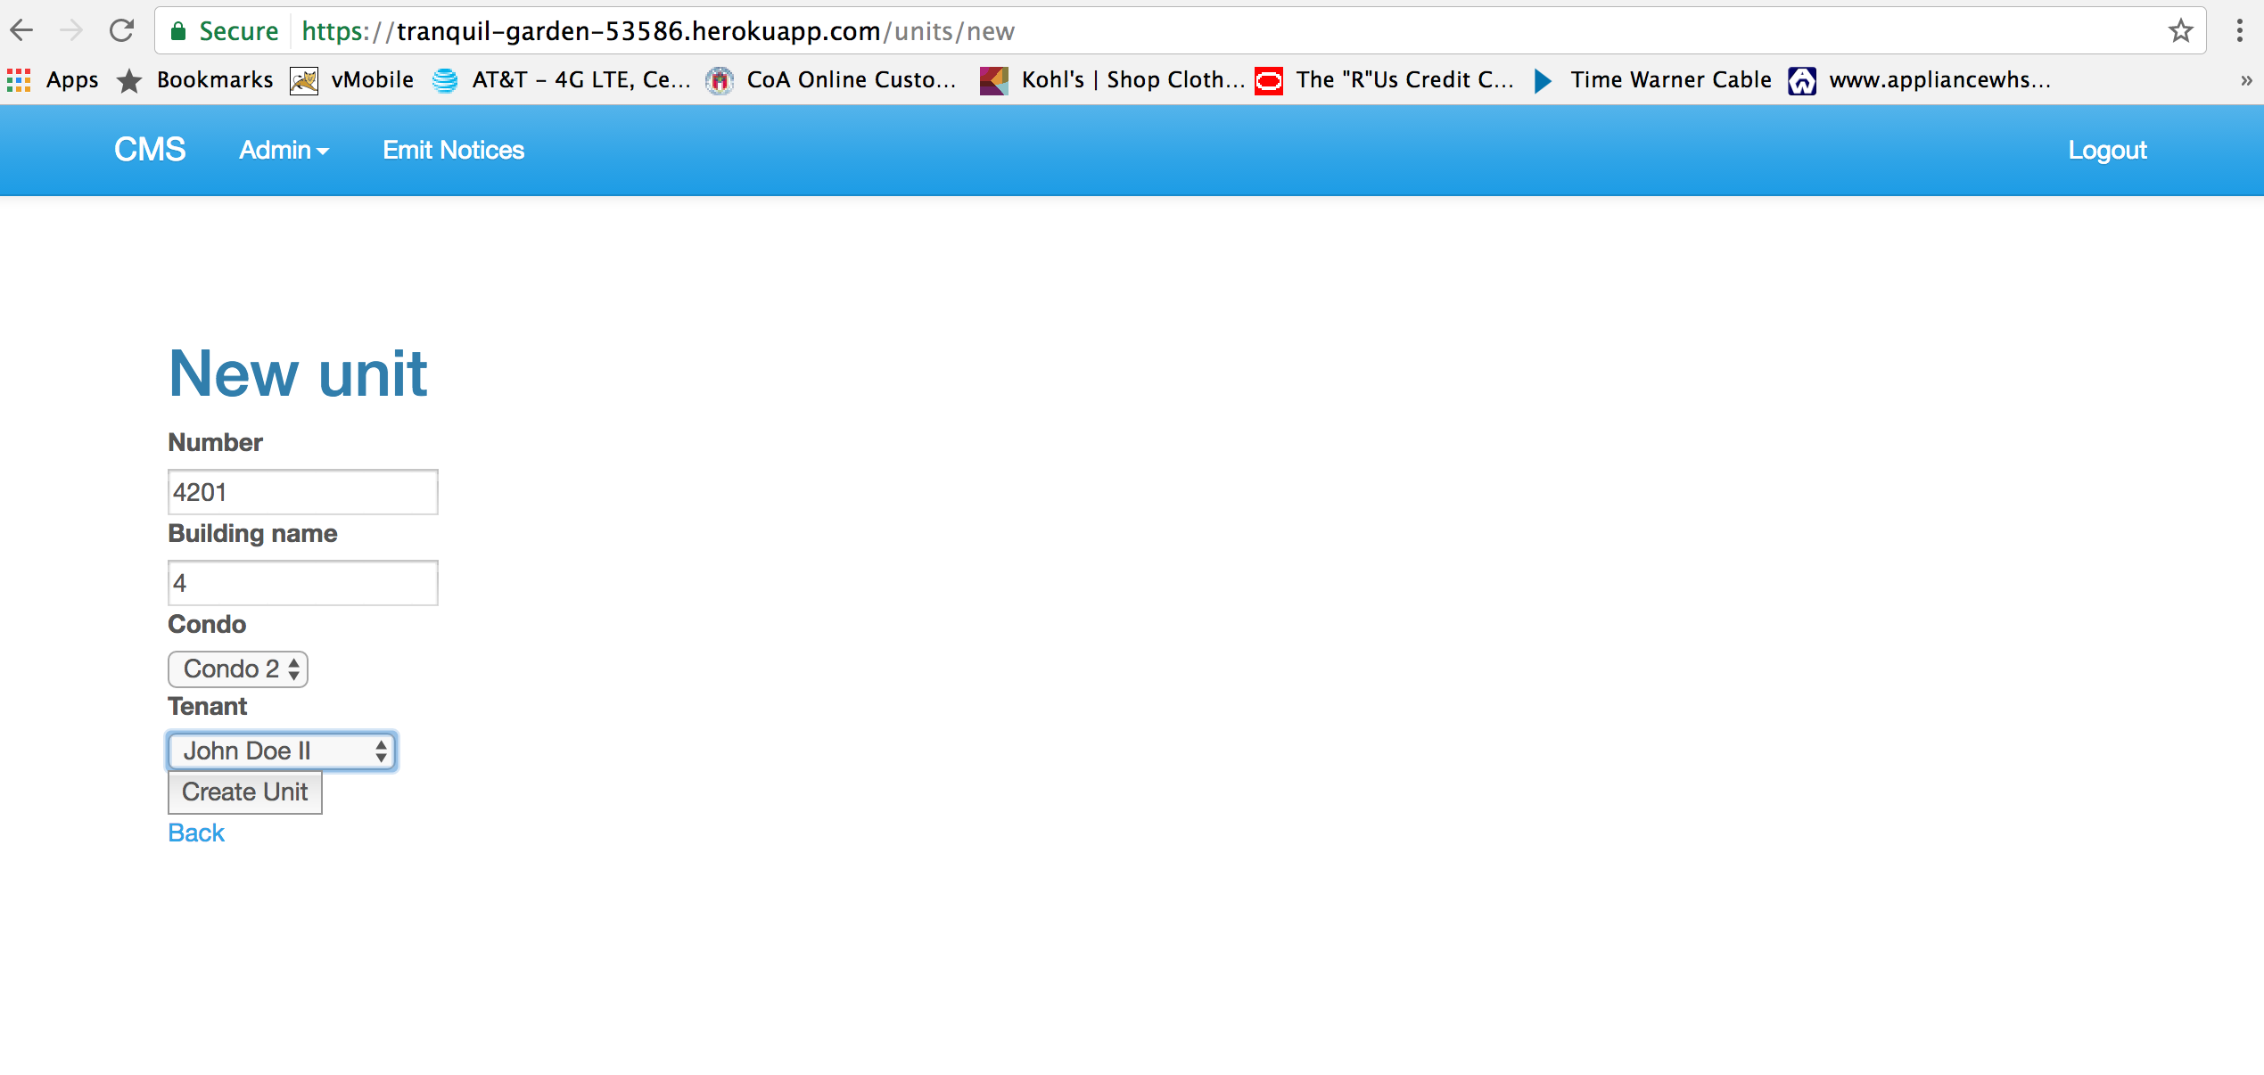

UNIT CREATED RESPONSE SCREEN

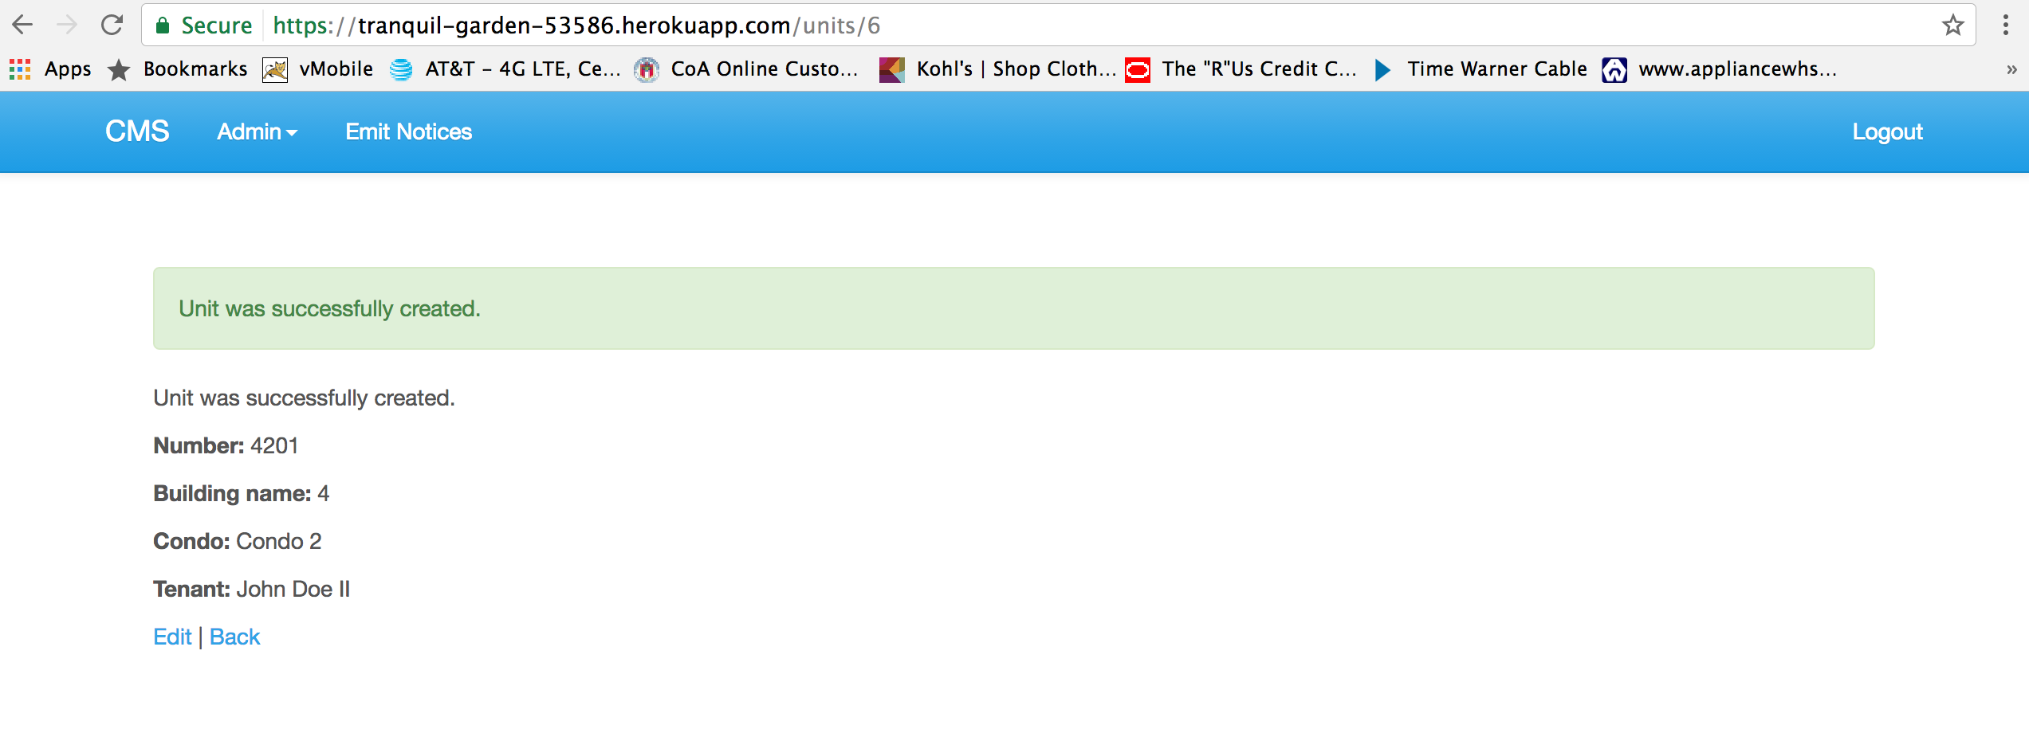

LIST OF UNITS AFTER ADDING THE NEW UNIT

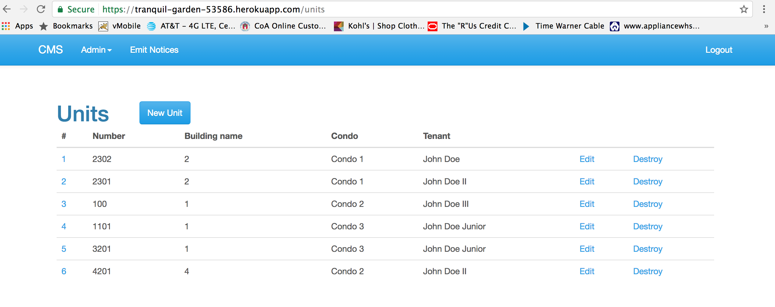

EDIT THE UNIT DETAILS

Precondition: Assert that user has logged in

Path:

1. User clicks on units from the Admin drop down menu.
2. User see the units list
3. User clicks on the Edit button
4. User updates the Tenants name residing in the unit

Requirements

1. User should be able to see the confirmation window.
2. User should be able to see the updated list.

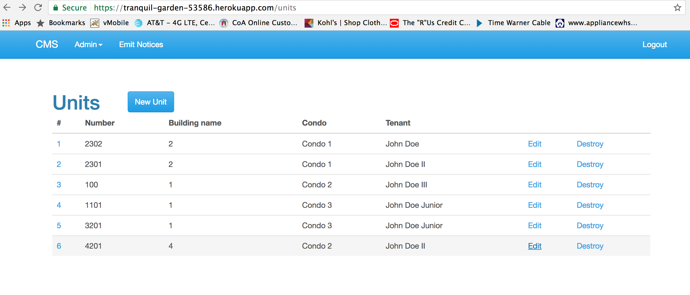

UPDATING THE TENANT NAME

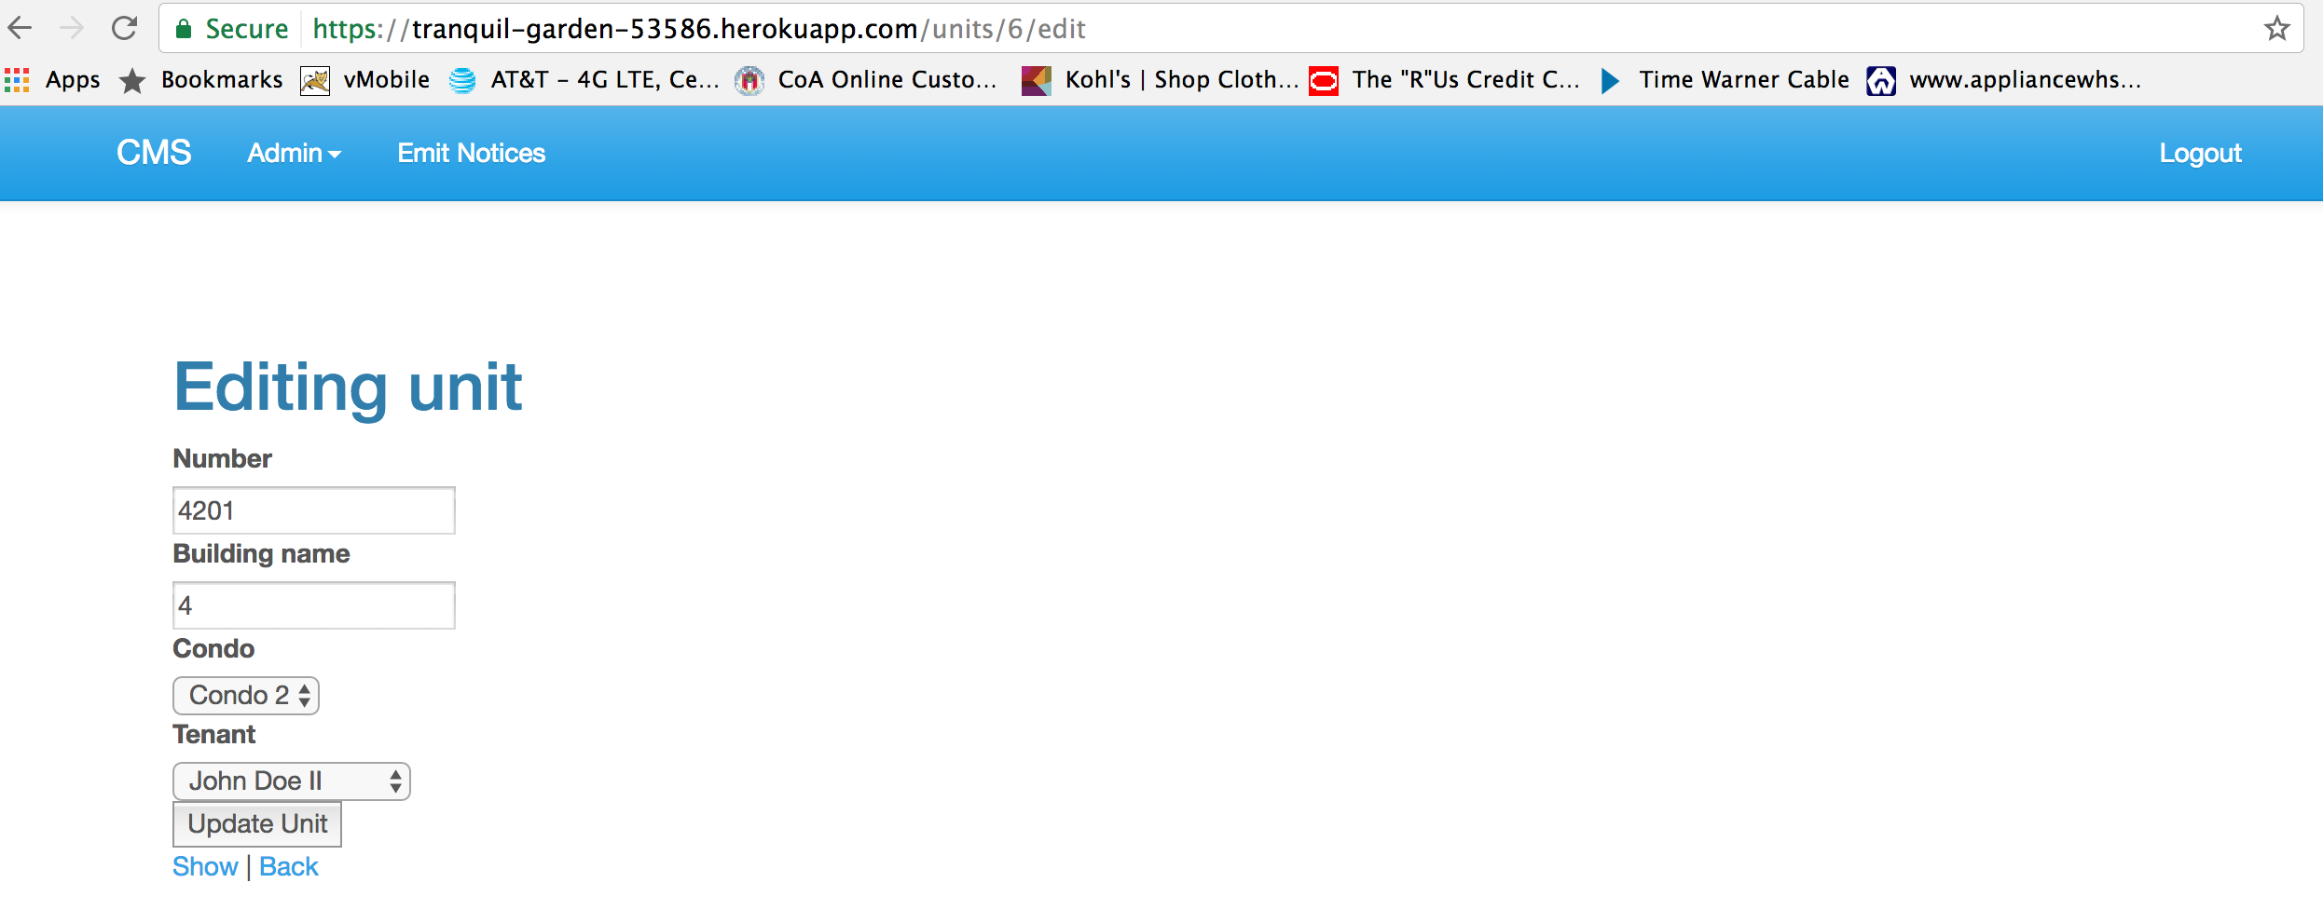

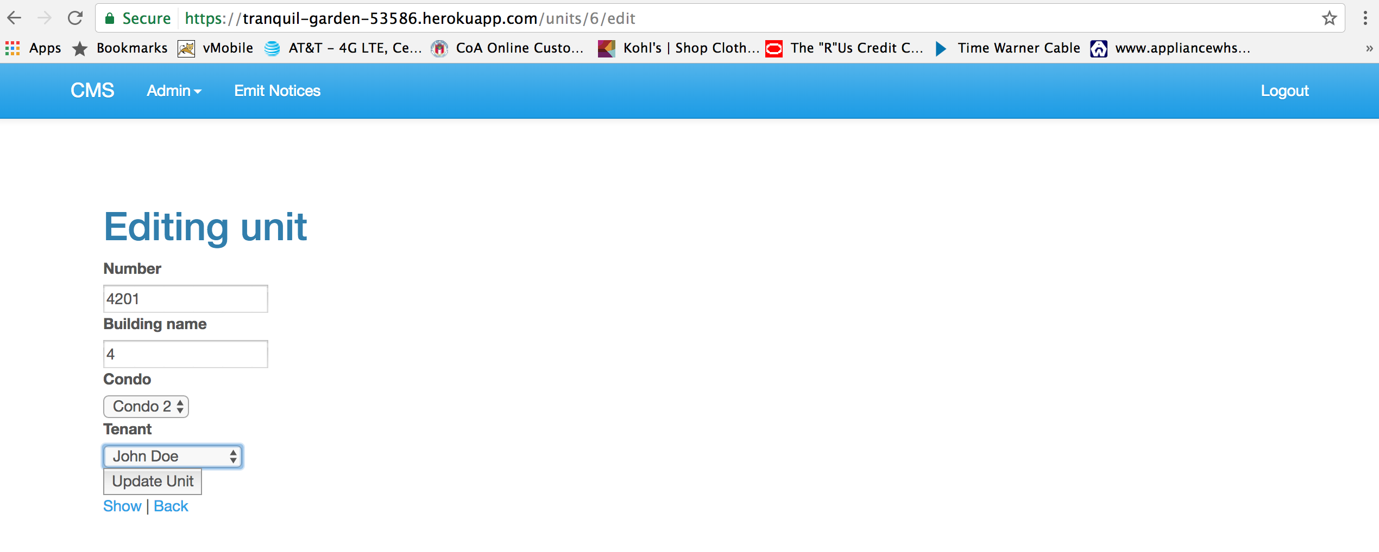

UPDATED THE TENANT DETAILS

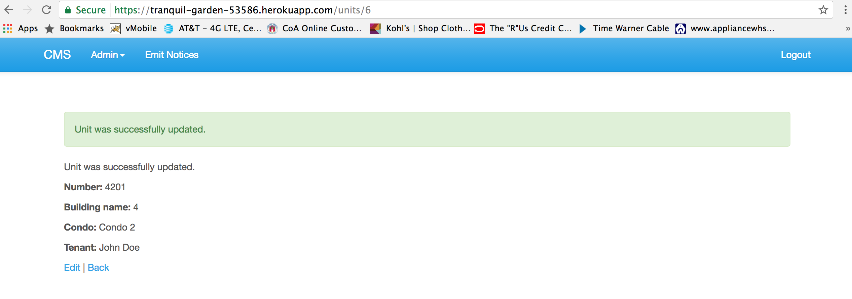

LIST OF UNITS WITH UPDATED UNIT DETAILS

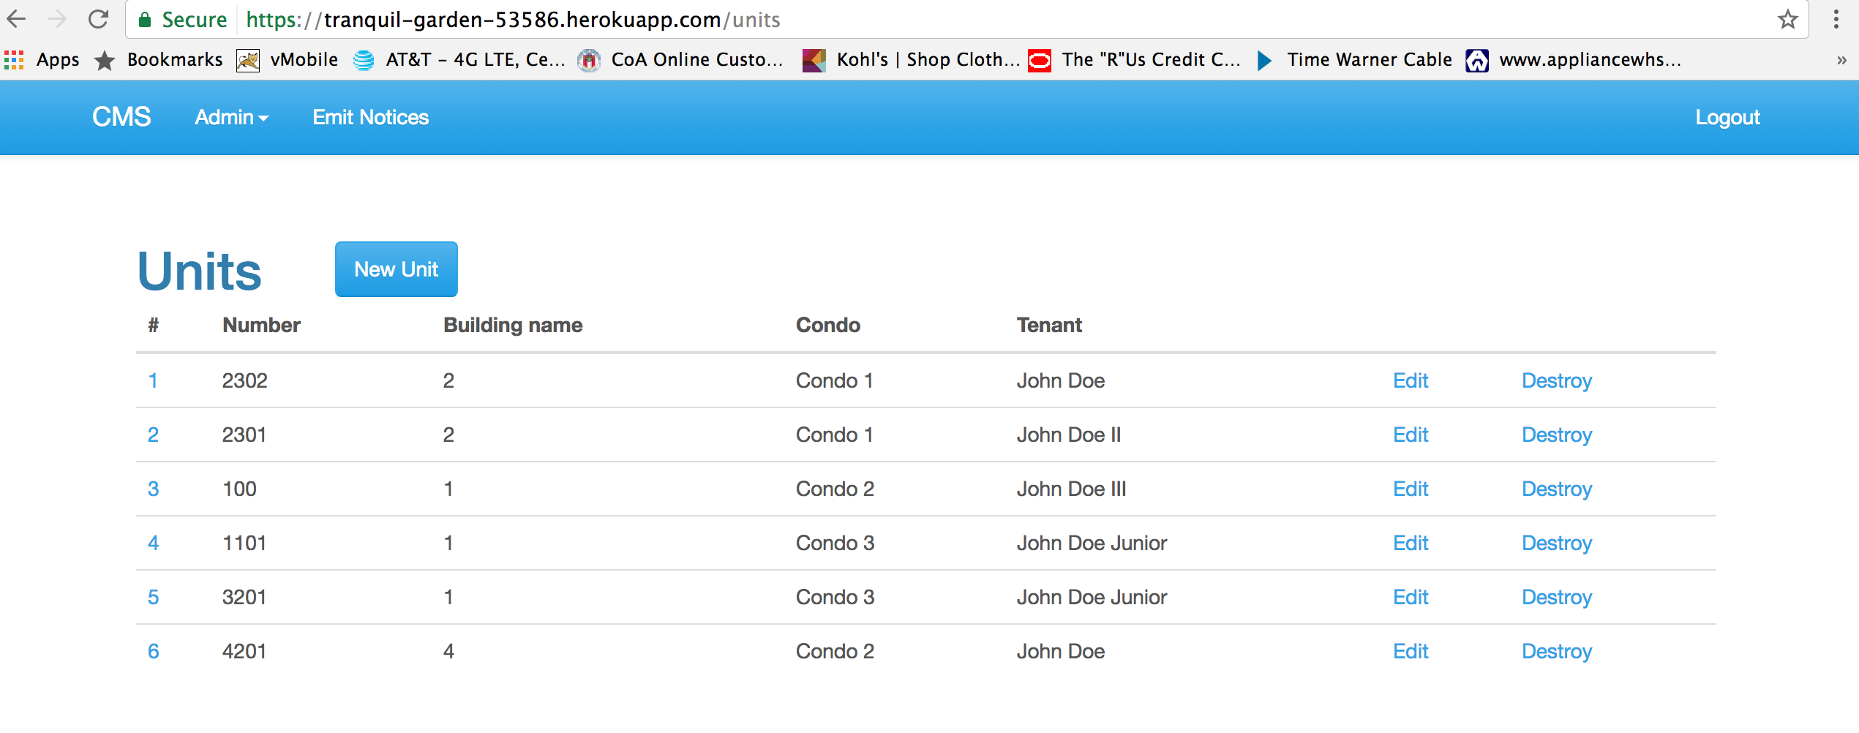

DESTROY THE UNIT

Precondition: Assert that user has logged in

Path:

1. User clicks on units from the Admin drop down menu.
2. User see the units list
3. User clicks on Destroy

Requirements

1. User should be able to see the confirmation window.
2. User should be able to see the updated list.

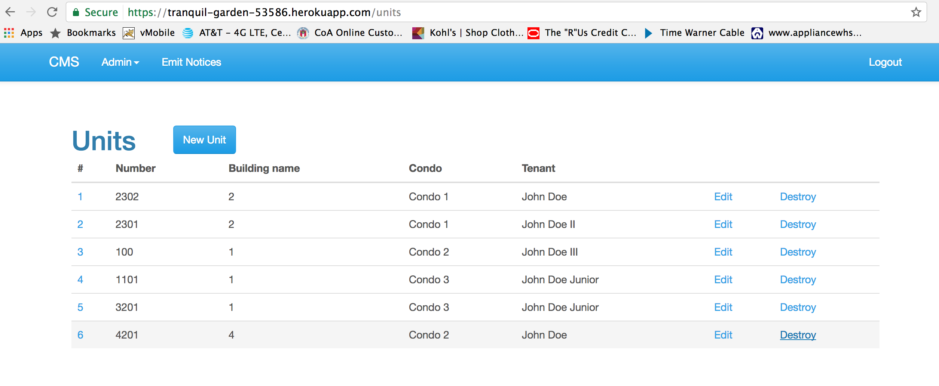

CONFIRMATION FOR DESTROYING THE UNIT

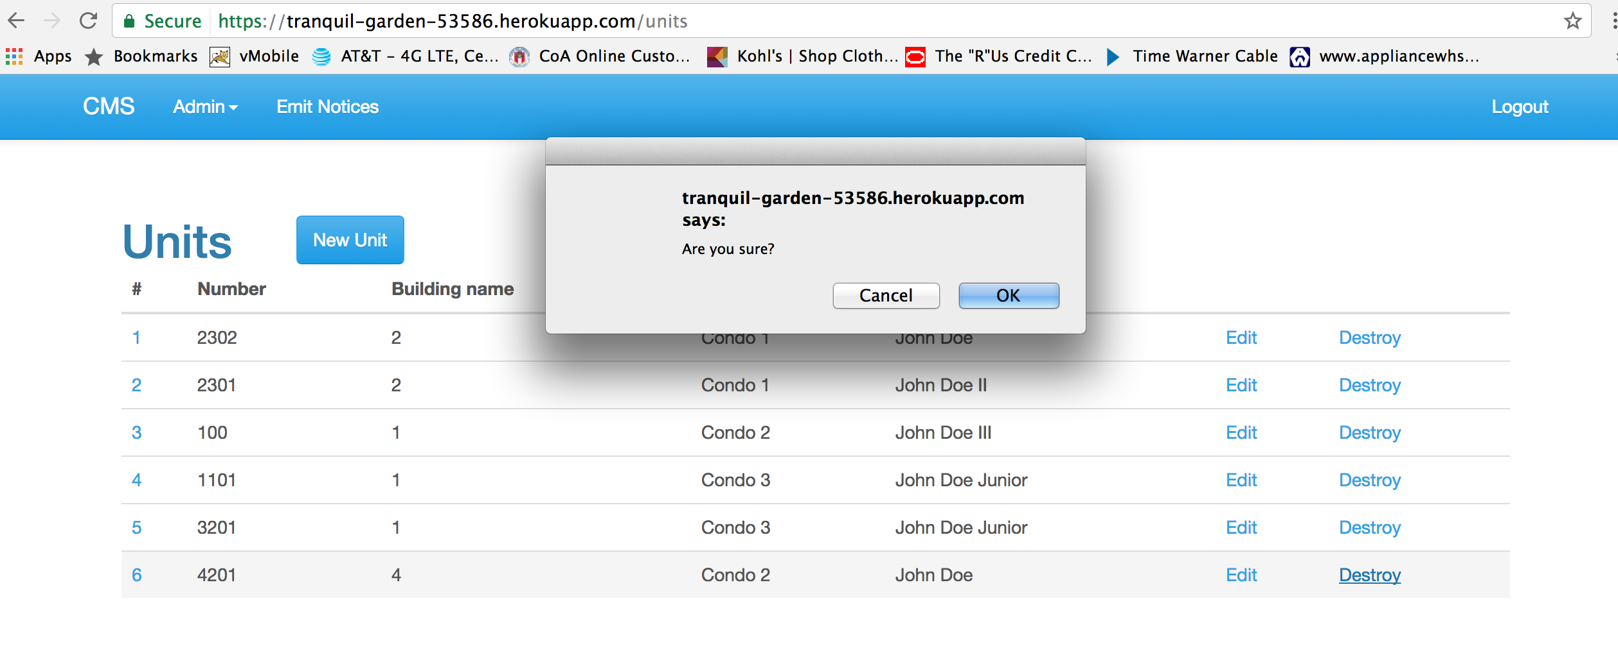

AFTER DESTROYING THE UPDATED UNIT LIST

